# Alphonz George

# T11-03

**Assignment 2**

**AIM:** To study AWS S3 service and create a bucket for hosting static web applications.

# THEORY:

AWS Simple Storage Service (S3) from the aforementioned list, S3, is the object storage

service provided by AWS. It is probably the most commonly used, go-to storage service for AWS users given the features like extremely high availability, security, and simple connection to other AWS Services. An Amazon S3 bucket can be set up to operate similarly to a website. This section illustrates how to host a website using Amazon S3. There are mainly 7 steps to hosting a static website using Amazon Web Service(AWS) S3.

## Step 1: Creating a Bucket

1. First, we have to launch our S3 instance. Follow these steps for creating a Bucket
2. Open the Amazon S3 console by logging into the AWS Management Console at https://console.aws.amazon.com/s3/.
3. Click on Create Bucket.



1. Choose Bucket Name – Bucket Name Should be Unique
2. Object Ownership – Enable for making Public, Otherwise disable

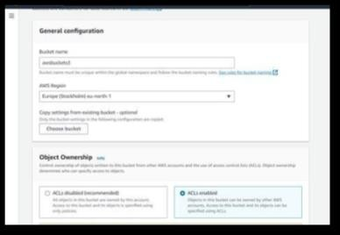

## Step 2: Block Public Access seFngs for the bucket

1. Uncheck (Block all public access) for the public, otherwise set default. If you uncheck (Block all public keys).



1. Now click on create bucket
2. Bucket is created



## Step 3: Now upload code files

Select Bucket and Click your Bucket Name.

Now, click on upload (then click add File/folder) and select your HTML code file from your PC/Laptop.



## Step 4: Once the Files are uploaded successfully, click on Permissions and now follow this Process –

* + Block public access
  + Object Ownership
  + Make public Object

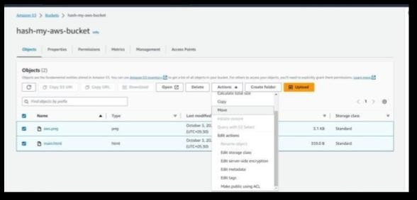

## Step 5: Copy your Object URL

Now, click on your HTML File Object Name. Copy the Object URL.

## Step 6: Check out your Website!

Directly Paste this URL into the Other Tab or your other System.

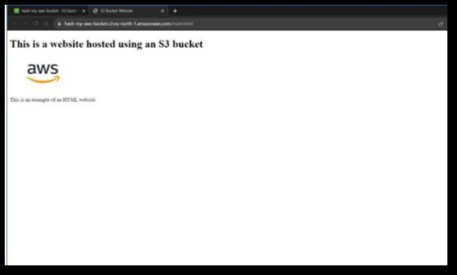

# CONCLUSION:-

This experiment demonstrated how to utilize AWS S3, a powerful and scalable cloud storage solution, to host a static web application. S3's ability to serve static content with low latency and high reliability makes it a suitable choice for hosting static websites. By completing this experiment, we gained practical insights into leveraging cloud services for web hosting, which is vital for modern web development and deployment. AWS S3 offers a cost- effective and efficient solution for hosting various types of web applications, contributing to the

agility and scalability of web development projects.